person



Inspiring and empowering future professionals

**Software Engineering Job Simulation**

Certificate of Completion

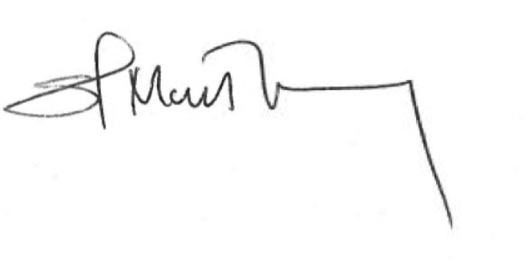month date, year

Over the period of month year, name has completed practical tasks in: Crack leaked password database



Enrolment Verification Code ueNyn7bk28M8qnXBN | User Verification Code fKn9q2BcYw7a4pjAR | Issued by Forage

**Matthew Chung** Global Chief Information Security Officer and Head of Technology Risk

**Tom Brunskill** CEO, Co-Founder of Forage